CODE SMELL

* LONG PARAMETER LIST

**Location in the code:** src/main/java/org/jabref/gui/groups/GroupNodeViewModel

The constructor of the class GroupNodeViewModel has to many parameters.

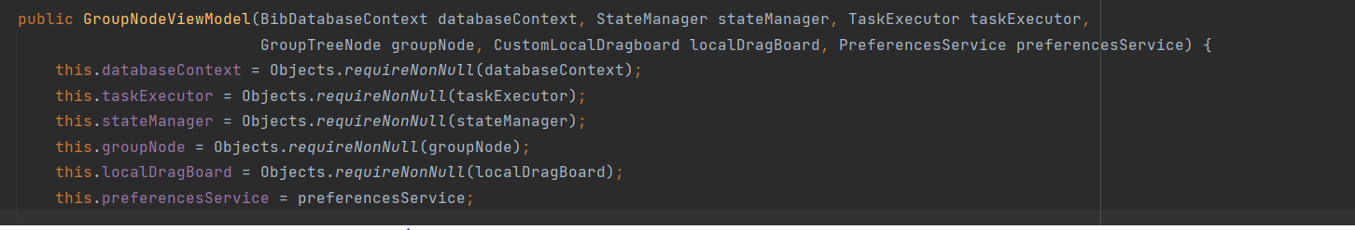

Refactoring may be a good way to solve it, and may even reveal previously unnoticed duplicate code.